COMPOSITION: ELECTRONIC MUSIC I
25:250
Fall, 2011
Assignment 4. Due Nov. 2

1. The assignment will be due in class on Wednesday, Nov. 2. Students may present the assignment on Monday,
Oct. 31 if they wish.

2. The purpose of Assignment 4 is to link all of the phrases from Assignment 3 together in Pro Tools, then apply
various transformations in Pitch n Time and Harmonic Maximizer to copies of the collection of regions. This will
result in a large number of variations that will serve as source material for the final composition.

3. Prepare the session for transformations as follows.
a. Move all regions to fit into 4 tracks, as shown below. 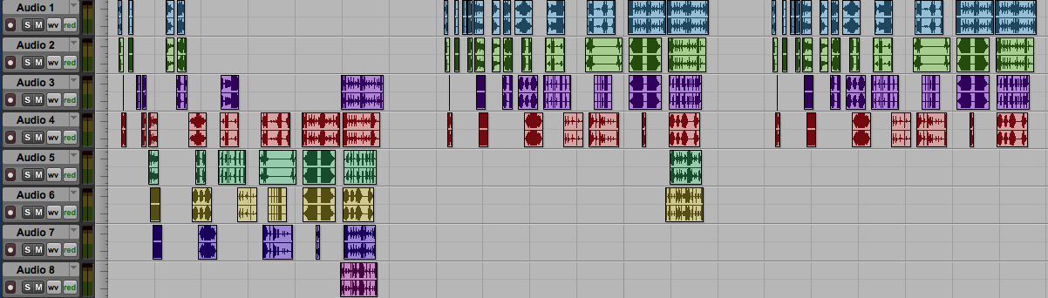
b. The example above shows this done in 3 steps.
c. The collection of regions on the left shows the original collection of regions using 8 tracks.
d. The collection of regions in the middle shows that each region was moved into tracks 1-4, with the exception
of the last phrase, which fits into 6 tracks. Notice that the time relations of the regions is not changed.
e. The regions on the right show that the regions in tracks 7-8 have been deleted, as will be discussed in class.
f. If the original collection of regions fits into fewer than 4 tracks, try to arrange them into 4 tracks by any
method.

4. Copy and paste the last collection of regions 4 times, as shown below.
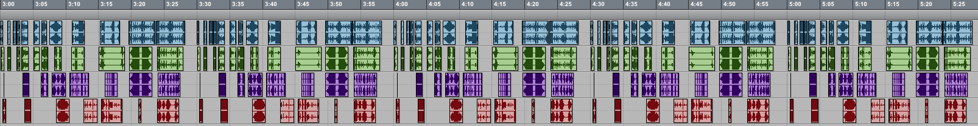
a. Note the start times for each copy. In the example, the original copy begins at 3:00. The second copy begins
at 3:30. The third copy begins at 4:00, followed by copies at 4:30 and 5:00.
b. As discussed in class, other start times should be used if the original length is shorter or longer.
c. The reason for controlling the start times is purely for organizational purposes. There is no musical
significance to the specific start times at this point in the project.

5. On paper, in Word, or in your head, create a table like the one below.
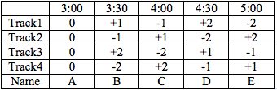
a. The left column shows the track numbers 1-4. The bottom cell will be explained below.
b. The top row shows the start times of 3:00 – 5:00.
c. The bottom row assigns the letters A-E to each copy.
d. The second column, named A, shows that each track has been transposed by 0 semitones, as discussed in class.
e. The third column, named B, shows that track 1 has been transposed by +1 semitones.
f. The Pitch n Time plug-in should be used for transposing, which will allow you to keep the timing unchanged.
g. The other transposition choices in this table will be discussed in class, using the concepts of maximum
variation between tracks, maximum variation within a track, and the possibilities for creating stepwise voice-
leading relationships in a track.

7. AudioSuite plug-ins often allow the user to specify how regions are affected by the process, as shown below.
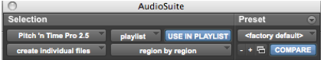
- In the middle of the bottom menus, “region by region” is selected. This treats every region independently.
- The other option is to select “entire selection.” This treats all selected regions of each track as a single unit.
- The menu on the lower left, “create individual files” is selected. This keeps every region independent of the others.
- The other option is to select “create continuous file.” This creates a single region for each track.

8. Copy region collections A-F and paste them to the right, at a convenient starting point. Then, create a table like
the one below.
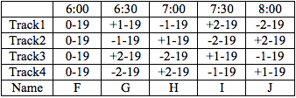
a. Notice that each track is transposed down -19 semitones.
b. Transposing this material to a lower pitch level brings the upper harmonics of each sound into a lower
register. Consider the effect of a high pass filter applied to these sounds, followed by their normalization.
However, this will not be done in this assignment.
c. Notice that that transposing these copies down -19 semitones results in no unison or octave transpositional
relations. This creates one the richest possible pitch-class transpositional space. Other transpositional levels
will be discussed in class.

9. To shorten the duration of each region, first create a table like the one below.
- As the table indicates, you should copy tracks A-J and paste them to the right of the previous tracks.
- We will continue to use the names A-J.
- Make the duration each individual region twice as short by using the Pitch n Time settings shown below:
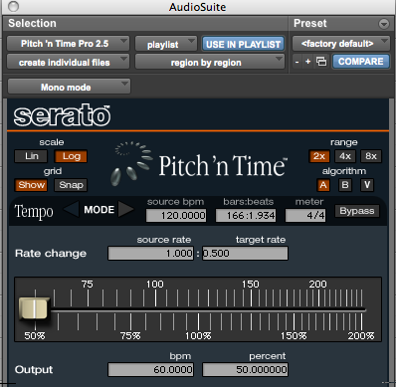
d. Notice that the options “create individual files” and “region by region” have been selected.

10. To make each region twice as long, create a table like the one below.
- As the table indicates, you should copy tracks A-J and paste them to the right of the previous tracks.
- We will continue to use the names A-J.
- Make the duration each individual region twice as long by using the Pitch n Time settings shown below:
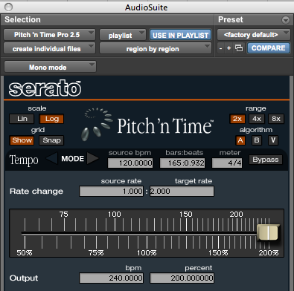

11. To change the timbre all of the sounds, one method would be to use an EQ plug-in. For this assignment, we will
use the BBE Harmonic Maximizer, found under EQ in AudioSuite.
- Note that this plug-in does not appear in AudioSuite presently. However, it does appear in Peak. Shane and
Zach will sort this out as soon as possible.
b. An example of the Harmonic Maximizer settings is shown below, and will be discussed in class.
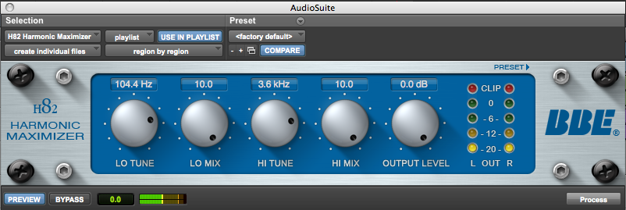

12. This concludes the work you will do in Assignment 4.

13. Discussion of how to use the regions that have been transformed in the final composition.

